Client | [Customer Name will be written here]
Project Name | [Project Name will be written here]

Table of Contents
1 Document Overview 3
1.1 Scope & Purpose 3
1.2 Version Numbers 3
1.3 Audience 3
1.4 Document Structure and Special Conventions 3
1.5 Definitions, Symbols and Abbreviations 4
1.6 References 5
2 Introduction 6
3 Interface Overview 7
3.1 Assumptions & Restrictions 7
3.2 Protocol Perspective 7
3.3 Data Type Definitions Used 8
3.4 Specification of Mandatory, Optional and Conditional parameters 9
4 Interface Definition for [Component1] to [Component2] Integration Point 10
4.1 Interface Identification Card 10
4.2 Interface Methods 11
4.2.1 Interface <method name-1> 11
4.2.2 Exceptions 11
4.2.3 Error Codes 11
4.2.4 Technical Interface Definition 11
4.2.5 Calling Sample 12
5 Complex Data Type Definitions 12
5.1 Data Type <Address> 12
5.2 Data Type <Complex Type-2> 12
5.3 Data Type <Complex Type-n> 12
Appendix 13
Document Control 13

Document Overview

Scope & Purpose
The present document aims to provide a technical description of the Interface ID [XYZ] as provided in Main Architecture Document.

Version Numbers

This Specification has been produced by the i2i Systems (i2i) following 3GPP specifications alike versioning scheme.

The contents of the present document are subject to continuing work and may be changed by i2i. Should the i2i modify the contents of the present document, it will be re-released with an identifying change of release date and an increase in version number as follows:

Version x.y.z
where:
x the first digit:
1 presented for information;
2 presented for approval;
3 or greater indicates approved document under change control.
y the second digit is incremented for all changes of substance, i.e. technical enhancements, corrections, updates, etc.
z the third digit is incremented when editorial only changes have been incorporated in the document.

Audience

The document may be read by the below audience;
- Business/System Analysts
- Solution/System Architects

Document Structure and Special Conventions
If the document is complex and specific sections apply to specific reader profile, a brief description of vital sections contained in the document shall be provided.
Such as;

Section X: Explains the details related to xyz providing diagrams. This section shall be read by Business Analysts
Section Y: Explains the details related to wqv from system perspective. This section shall be read by Solution Architects
Etc.

Definitions, Symbols and Abbreviations

TERM | DESCRIPTION
API | Application Programming Interface
ASN.1 | Abstract Syntax Notation 1. An abstract syntax notation, which is used to describe data and data structure.
BGW | Billing Gateway
BRS | Business Requirements Specification
BSS | Business Support System
CDR | Call Data Record – Records in files generated by external network nodes such as MSC, SDP etc.
DWH | Data Ware House
EDIFACT | Electronic Data Interchange For Administration, Commerce and Transport. EDIFACT indicates a format
EIR | Equipment Identity Register
FMS | Fraud Management System
GUI | Graphical User Interface
HTML | Hyper Text Markup Language.
HTTP | Hyper Text Transfer Protocol. Simple stateless protocol used throughout the internet.
IVR | Interactive Voice Response System
Java | An object orientated programming language which is portable between platforms.
MML | Man Machine Language, specifies the command format API of the HLR
OSS | Operations Support System
SAS | System Architectural Specifcation
SOAP | Simple Object Access Protocol  SOAP is a simple XML-based protocol to let applications exchange information over HTTP
SRS | System Solution Requirements Specification
VAS | Value Added Service
XML | Extensible Markup Language. A widely used standard mark-up language.
XSD | XML Schema Definition. XML Schema is an XML based alternative to DTD. An XML schema describes the structure of an XML document.

References
- SRS_SystemRequirementsSpecifications_[Area]_[ProjectCode]_ v1.1.1.doc, System/Solution Requirements Specifications, Feb 2009, i2i-Systems
- SUC_SystemUseCases_[Area]_[ProjectCode]_V1.1.1, System Use Case Specifications, Feb 2009, i2i-Systems
- [Document Name], [Document Abstract], [Date], [Owner Company or Name]
- [Document Name], [Document Abstract], [Date], [Owner Company or Name]
- [Document Name], [Document Abstract], [Date], [Owner Company or Name]

Introduction
This document describes the integration between the <Component A> and <Components>. The following figure depicts the High-Level Architecture of [XXX Project] solution and this document corresponds to the highlighted section below:

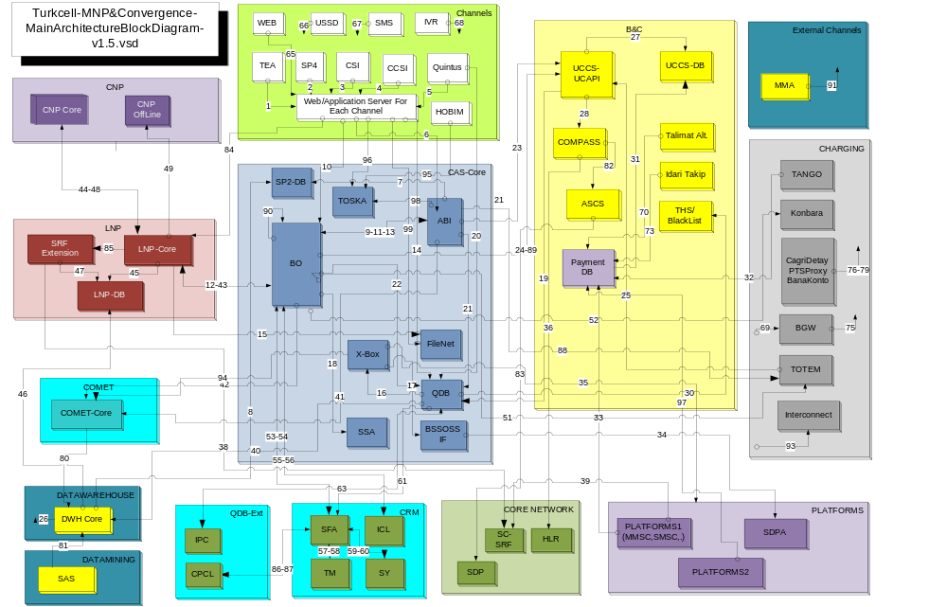

Figure 1: Overall Solution Architecture

Interface Overview

Assumptions & Restrictions

ID | Assumption

Protocol Perspective

This interface uses Web services to publish its functionality to the rest of the world. More technically, the protocol used is SOAP.

SOAP is a simple XML based protocol to let applications exchange information over HTTP. SOAP uses XML to marshal data that is transported to a software application and HTTP to transport it over the network. SOAP defines more than one data encoding method to convert data from a software program into XML format and back again.
Additional technical specification of this interface is provided as a WSDL document which refers to a XSD document. The WSDL specifies the location of the service and the operations (or methods) the [AREA] web service exposes. The XSD document further details the complex data types used by the web service operations.
Since SOAP's introduction, three SOAP encoding styles have become popular and are reliably implemented across software vendors and technology providers:
- SOAP Remote Procedure Call (RPC) encoding, defined by the SOAP 1.1 specification.
- SOAP Remote Procedure Call Literal encoding (SOAP RPC-literal)
- SOAP document-style encoding, also known as message-style or document-literal encoding.
This interface uses document-style encoding due to the following reasons:
- Better performance and less XML parsing overhead introduced
- Possibility to validate the SOAP message with any XML validating tool. Everything within the soap:body is defined in a schema.
- Document/literal is WS-I compliant (Web Service Interoperability Organization)

Data Type Definitions Used

The following convention will be used to define the Data Types of parameters:

TYPE IDENTIFIER  SYMBOL | DESCRIPTION
N | Decimal digits 0 through 9
S | Signed numeric digits 0 through 9 optionally starting with ‘+’ or ‘-‘
F | Signed floating point number optionally starting with ‘+’ or ‘-‘.The decimal point may be either “,” or “.” depending on UCCS configuration settings.
A | A string containing alphanumeric characters
Date | A string representing a date in the format “DD/MM/YYYY”  YYYY= year including the century  MM = month of the year (with leading zeroes)  DD = day of the month (with leading zeroes)
Datetime | A string representing a date & time in the format  “DD/MM/YYYY-HH24:MI:SS”  YYYY= year including the century  MM = month of the year (with leading zeroes)  DD = day of the month (with leading zeroes)  HH24= hour of the day (00-23)  MI= minute (00- 59)  SS= second (00-59)
Boolean | A single character string representing a boolean value.  ‘Y’, ‘y’: Means Yes or TRUE  ‘N’, ‘n’: Means No or FALSE
T: el_name | Complex Data Type definition: Refers to a complex Data Type Definition (see section 5) named as <el_name> that may contain either ONE OF or BOTH OF the below;  - A sequence of attributes of type N, S, F, A, Date, Datetime, Boolean  - A sequence of other sub complex elements/types.
{memberel_name} | Indicates a LIST of “T: memberel_name”. LIST is a special form of  T: el_name which contains only a sequence of sub elements of “T:memberel_name”.
The above definitions for “N”, “S”, “F”, “A” and {memberel_name} can be followed by a number indicating the length, or one or two numbers separated by two dots indicating variable length or number of elements in a list with min and max.

e.g.

N means unspecified number of decimal digits
N15 means exactly fifteen decimal digits.
N2..7 means between two and seven decimal digits.
N..12 means not more than twelve decimal digits.

A means string of unspecified number of characters
A4 means a string consisting of exactly 4 characters
A2..12 means a string between two and twelve characters
{A} means an unspecified list of strings
{A}2..4 means a list of strings having minimum two members and maximum 4 members
{Address} means a list of Addresses where Address is a complex type.
{Address}2.. means a list of Addresses where a minimum of two addresses required.
F1..3 means min 1 max 3 digits after decimal separator.
F0..4 means upto 4 digits after decimal separator
F..4 means upto 4 digits after decimal separator
F4 means exactly 4 digits after decimal separator

Specification of Mandatory, Optional and Conditional parameters

A Request to an interface method may contain any combination of mandatory and optional parameters. The mandatory parameters are flagged in a specific “Mandatory” column within the tables that describe interface.
All mandatory parameters are flagged as “Y” in Mandatory column. All other parameters are optional if Mandatory column is not flagged.
Note that some optional parameters may be required in some circumstances, dependent upon other optional parameters. These parameters are marked as “C→”. The conditional details are provided in the next “Remarks” column together with other supplementary information.

Interface Definition for [Component1] to [Component2] Integration Point

Interface Identification Card

Interface Characteristic | Description
Interface ID
(as given in Main Architecture document)
Source Application(s)/Module(s)
(as given in Main Architecture document)
Destination Application(s)/Module(s)
(as given in Main Architecture document)
Protocol | RCP over TCP  Corba  Web Server (http-SOAP)  RMI  Etc.
Client Interaction Type | Synchronous  Asynchronous
Frequency Classification | Realtime (if <500ms)  Online (if <5sec)  Near Realtime (< 3min)  Offline (else)
Frequency/Response | 500ms  <5sec  <10min etc
Calling Classification | Function Oriented  Message Oriented

Interface Methods
List the methods of interface and give a brief description for each method:

Interface <method name-1>

Input Parameters
Parameter Name | Data Type | Description | Nullable | Mandatory | Remark
ID | N1..12 | Customer ID |  | Y
ParentID | N1..12 | Parent Customer ID |  | C→ | Must be provided if sub account
AddressList | {Address}2..4 | Min 2 max 4 addresses (See section 5 for complex type definition)
Describe details of the each parameter.

Output (Returning) Parameters
Parameter Name | Data Type | Description | Nullable | Mandatory | Remark
Describe details of the each parameter.

Exceptions
Name/ID | Area | Description
Describe details of the each parameter.

Error Codes
Error Code | Area | Description
Describe details of the each parameter.

Technical Interface Definition
Put RMI, WSDL, XSD, Database Table definition etc. as a text and also as a file object.

Calling Sample

Sample 1
Examples should be meaningful and consist of each method and each parameter usage details and hints. Please insert documents as text and as a file.

Sample n
Examples should be meaningful and consist of each method and each parameter usage details and hints. Please insert documents as text and as a file.

Complex Data Type Definitions

Data Type <Address>
Parameter Name | Data Type | Description | Nullable | Mandatory | Remark
Street | A1..64 |  |  | Y
No | N1..12 |  |  | Y
City | A1..32 |  |  | Y
PK | A1..10 |  | Y

Data Type <Complex Type-2>
Parameter Name | Data Type | Description | Nullable | Mandatory | Remark

Data Type <Complex Type-n>
Parameter Name | Data Type | Description | Nullable | Mandatory | Remark

Appendix

Document Control

Superseded Documents
- N/A

Change Control & Distribution
Owner | [OWNER NAME]
Reviewer
Approved By
Distribution
File Name | 0000.doc

Version History
Version | Change Descriptions | Author | Date
1.0.0 | Initial Version | [Author Name] | 01/Jan/2014

Approvals
This document requires the following approvals:

Name | Title | Date | Signature | Version

